- Background research
  - Why RQ is of interest (research gap and future directions according to the literature) (100 words)
While the previous research has examined national and international datasets, there is an analysis of district-level data from the major urban centres like New York City. This research question addresses this gap by testing gender similarities in mathematics performance hold in a specific diverse urban educational context over multiple years. Future studies tracked students over time to find out about their math skills development. It would also be useful to know how background or income affects performance. Looking at classrooms and teachers might give more clues about why students do better than others.
- Visualisation
  - Appropriate graphs for the RQ (50 words)
A box plot visualizes comparing of mathematic scale scores between male and female students. This visualisation displays average scores and gender comparisons. And histogram with a normal curve helped check whether the scores were roughly normally distributed. Together these visualizations make it easier to see patterns in the data and support our analysis of whether there are differences of mean in math performance between the two genders.

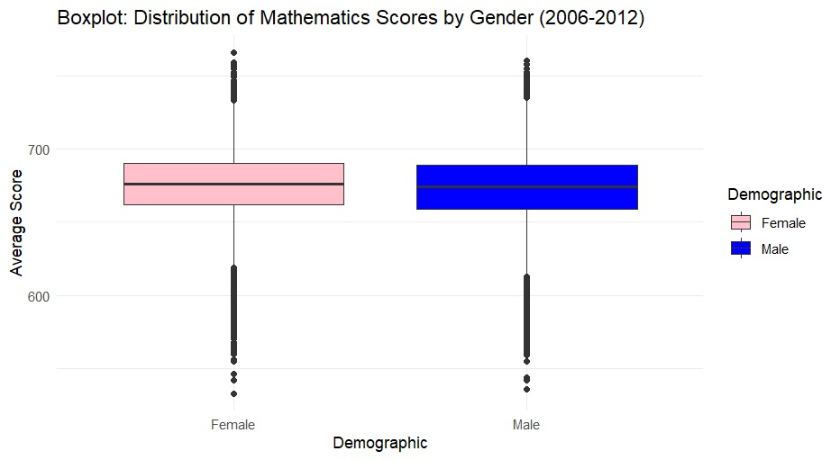

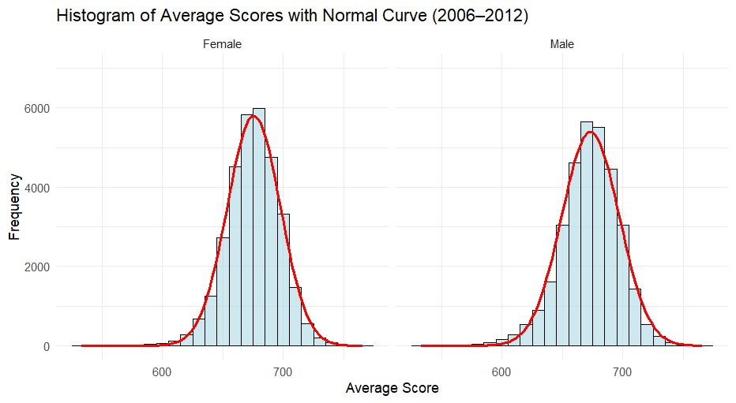

  - Additional information relating to understanding the data (optional) (50 words)
The histogram shows normal score distributions for both gender male and female, score distribution for each gender separately also showing the range and frequency of scores achieved by students. The boxplot shows overlapping distributions. Both visualizations indicate minimal difference between male and female students score patterns.

  - Useful information for the data understanding (50 words)
Key observations include similar score distributions for both genders, almost normal distributions. No clear visual differences were observed, suggesting potential support for the null hypothesis of no significant gender difference. The Boxplot reveals minor variations in mean scores , but no consistent gender advantage. Histograms show similar distribution patterns for both genders across years.

